**Lab Report - Use of Proxy chain AND Iptables**

Course Code - Course Name: - COMP4041 - Operating System

Program: T433 - Cybersecurity

Term: - Winter 2024

Lab Number - Topic: Lab 6 - Use of Proxy chain AND Iptables

Student Name - ID: Prabhjot Singh Sains – 101495218

**Part 1- Proxychains Exercises**

1. **Screenshot of IP address before using Proxy-chain.**

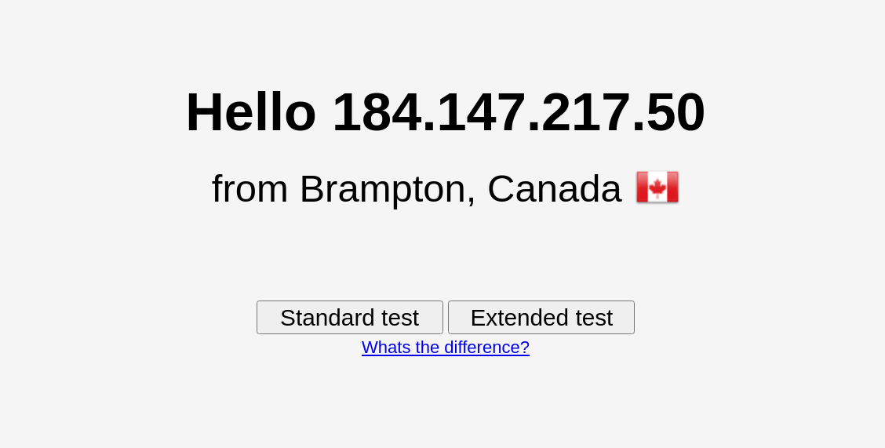

1. **Screenshot of the proxychains.conf file with updated configuration.**

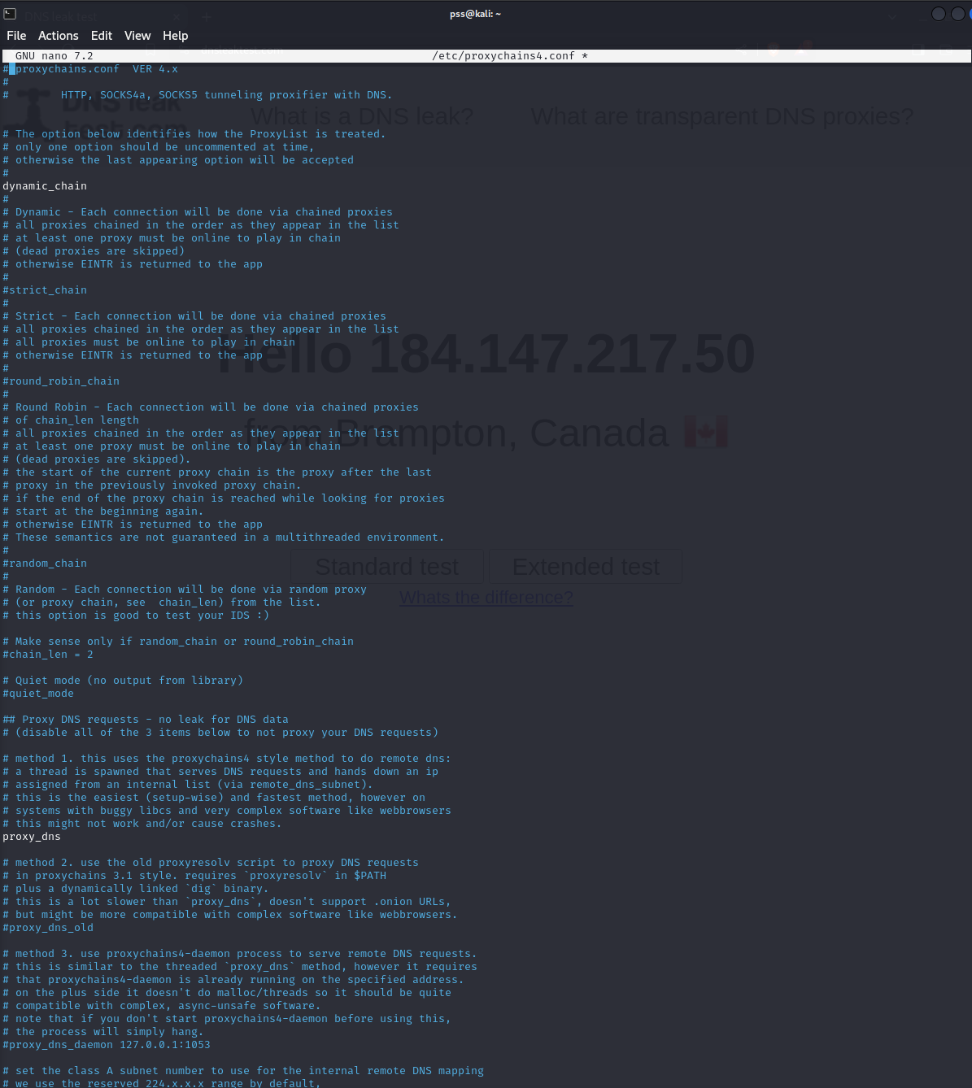

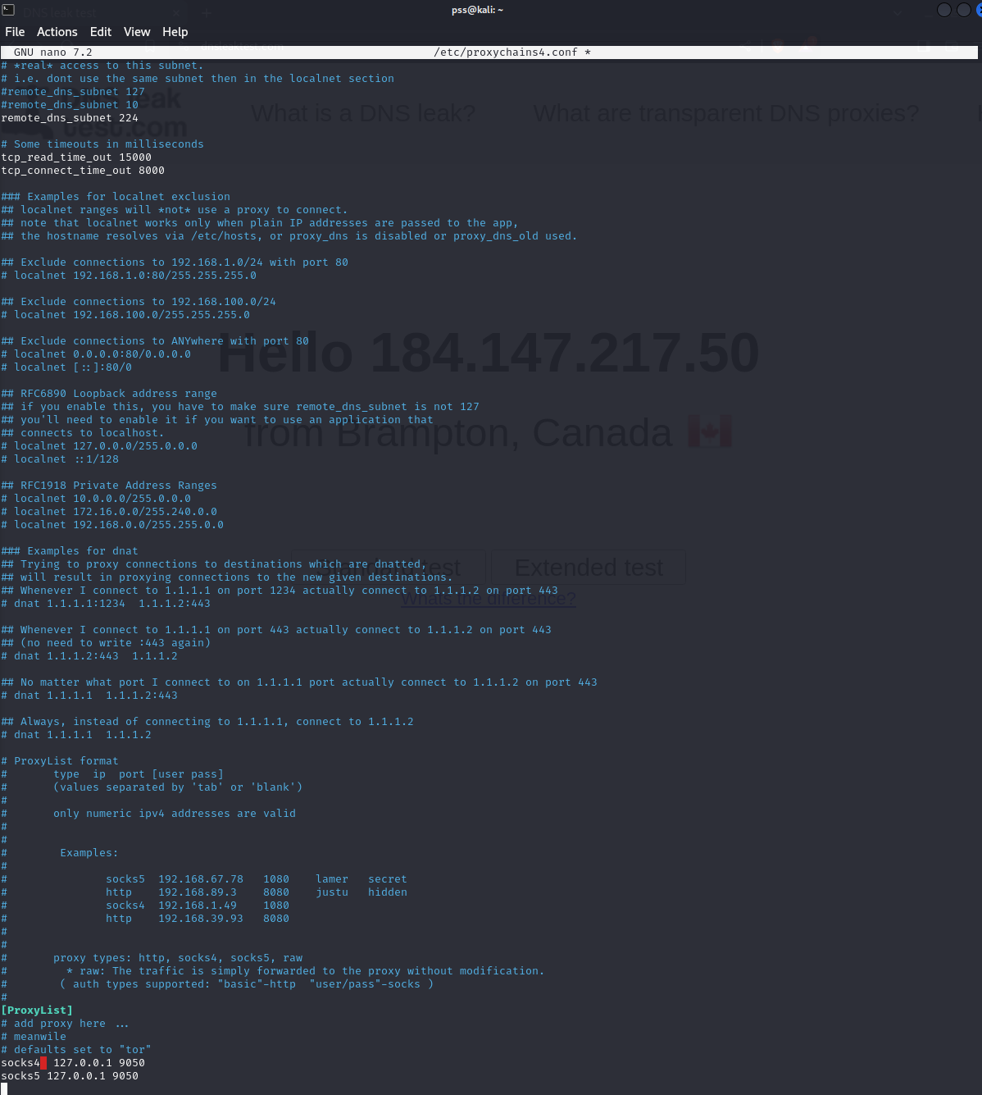

1. **Screenshot of IP address after using Proxy-chain.**

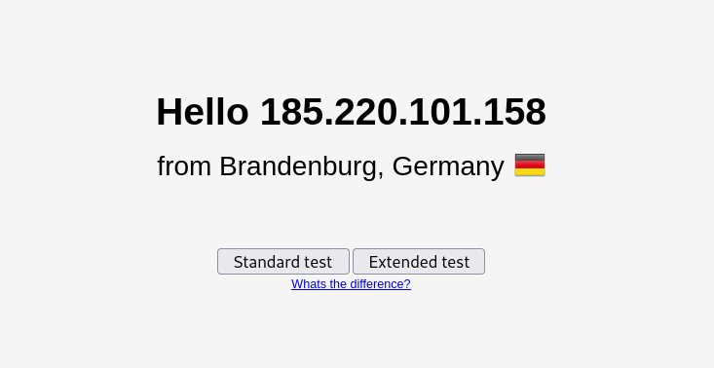

**Part 2- IP Tables Exercises**

1. **Forward all incoming HTTPS requests.**

sudo iptables -A INPUT -p tcp --dport 443 -j ACCEPT

1. **Reject all incoming packets for ICMP requests.**

sudo iptables -A INPUT -p icmp -j REJECT

1. **Reject all incoming packets for SSH connections.**

sudo iptables -A INPUT -p tcp --dport 22 -j REJECT

1. **Block all incoming packets for TELNET connections.**

sudo iptables -A INPUT -p tcp --dport 23 -j DROP

1. **Block all incoming packets for HTTP requests.**

sudo iptables -A INPUT -p tcp --dport 80 -j DROP